**Objective:**

The objective of this assignment is to collect financials from the CDS table in N-Q, and N-CSR reports of SEC/EDGAR database servers. The information from the CDS tables need to be saved in the usable format such as excel or csv.

**Input:**

Input.xlsx

**Expected Output:**

Examples

1. 20170727 Sample Output Phase 1.xlsx
2. 20170727 Sample Output Phase 2.xlsx

**Phase 1:**

Collect CDS table data with texts and table components / information. Search Keywords: CDS, Credit Swap, Credit Default Swap, Credit Default Swaps

Note:

1. The net notional is sometimes in (000s), keep track of it in output file.
2. The unrealized appreciation/depreciation is also sometimes in (000s), keep track of it in output file.

**Phase 2:**

Text analysis of CDS Text to parse text and extract i). ii). iii) and iv) as below. Develop patterns and develop regex (regular expressions) to identify and extract following:

i) Underlying

iii) Counterparty

iii) Exact underlying bond

iv) Identify whether the CDS transaction was a “Buy” (get insurance) or a “Sell” (provide insurance).

Note:

Sometimes we may miss the identification of the counterparty when the mutual fund sells the CDS – the phrasing is usually “Receive from …” for example “Receive from Morgan Stanley, Inc., upon default”.

Example:

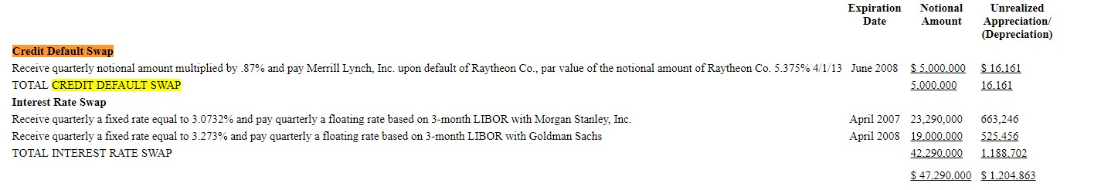

CDS Text: “Receive quarterly notional amount multiplied by .87% and pay Merrill Lynch, Inc. upon default of Raytheon Co., par value of the notional amount of Raytheon Co. 5.375% 4/1/13”

CDS Text contains a lot of useful information, the way it is reported varies from report to report.

i) Underlying (Raytheon Co.)

ii) Counterparty (Merrill Lynch)

iii) Exact underlying bond is the Raytheon Co 5.375% 4/1/13.

iv) CDS Transaction = “Sell” (provide insurance)

**What to Submit?**

**Phase 1:**

An excel file containing all columns of input data, CDT table indicators (components), and corresponding values.

|  |
| --- |
| ID |
| CIK |
| Company Name |
| Date Filed |
| Filename |
| Form Type |
| URL |
| Attributes |
| Values |

**Phase 2:**

An excel file continuing all columns of input data, CDS text and all components extracted from it.

|  |
| --- |
| ID |
| CIK |
| Company Name |
| Date Filed |
| Filename |
| Form Type |
| URL |
| CDS Text |
| Underlying |
| Exact Underlying |
| Counterparty |
| CDS Transaction |

Send your submission to [ajay@blackcoffer.com](mailto:ajay@blackcoffer.com) along with resume.